**Week 4 Lab Assembler**

**Group 65**

**Integrants: 110504517 李睿穎 (Leader)，110504518 鍾秉均 (Member)**

**Full Code**

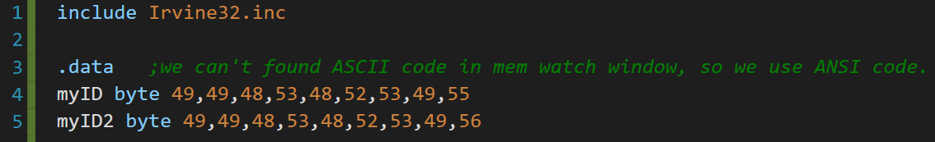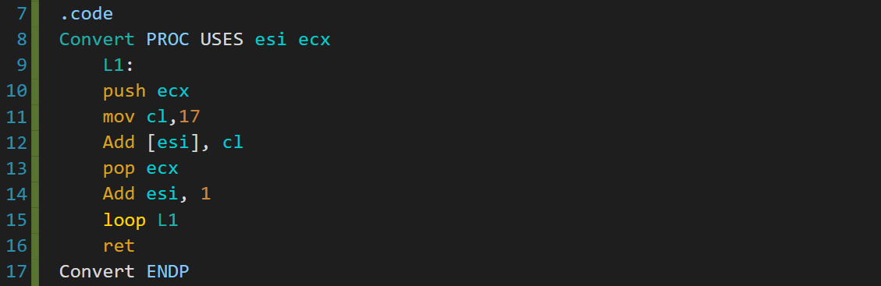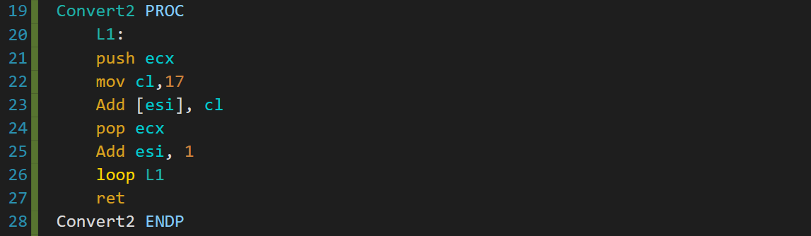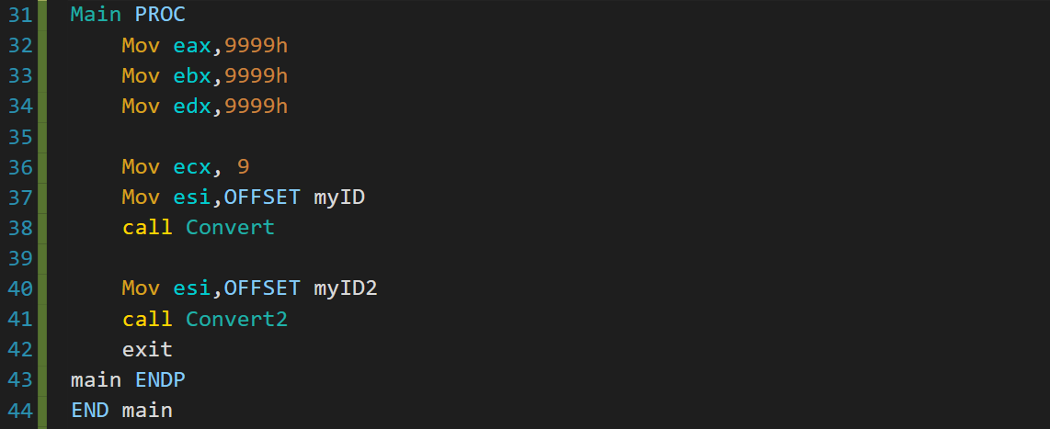

**Main Execution flow**

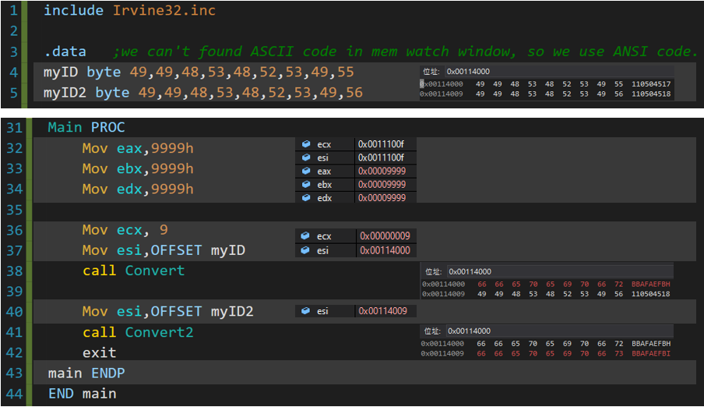

First we store an array with the corresponding values of our student number in ANSI code (We used ANSI code because we didn’t find ASCII code in the memory watch window)

Then what we do in main is just setting up things like eax, ebx and edx, set the number of loops, set esi and call the functions.

**Convert Execution flow**

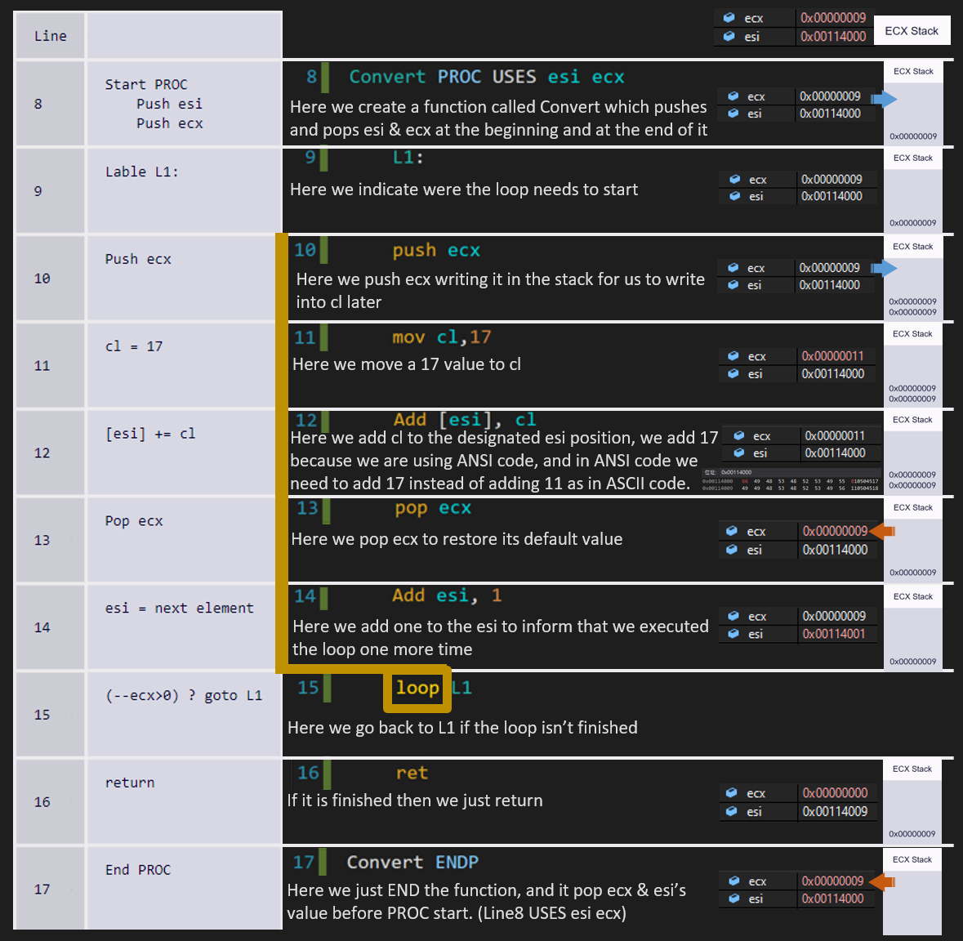

**Reflection**

For today’s lab experience we learned how to code functions and implement them, we also learned new things about assembler such as how to use the USES operator, PUSH and POP operator, and getting a deeper understanding on how loops work on assembler.

about the uses of “esi” and “ecx” registers in looping, which both of them function as our index, one being as the “limit” and the other being our pointer.